Student Name: Komal Barnwal
Registration No.: 11803231(A26)
Email ID: komalbarnwal2016@gmail.com
GitHub Link:

Problem: Three students (a, b, c) are arriving in the mess at the same time. The id numbers of these studends are 2132, 2102, 2453 and the food taken time from the mess table is 2, 4 and 8 minutes. If the two students have same remaining time so it is broken by giving priority to the students with the lowest id number. Consider the longest remaining time first (LRTF) scheduling algorithm and calculate the average turnaround time and waiting time.

Answer: LRTF is to be used here and this is a preemptive version of Longest Job First scheduling algorithm. We find the process with maximum remaining time and process it, in algorithm. We examine for maximum remaining time after some interval of time to examine if another process having more Burst Time arrived up to that time.

Algorithm:

Step 1: make a table of process containing all necessary fields like AT(Arrival time), CT (Completion Time), BT (Burst time), WT (Waiting Time), TAT (Turn Around Time).
Step 2: Sort the table accordion to Arrival Time (AT).
Step 3: Find the process having largest burst time and execute for each single unit.
Step 4: Increase the total time by 1 and reduce the burst time of that process with 1.
Step 5: When any process has 0 burst time left, then update the completion time of that process completion time will be Total time at that time.
Step 6: After calculating the CT for each process, find TAT and WT.

Formulas Used:

Turn Around Time: Time difference between completion time and arrival time.
Completion Time: Time at which process complete its execution.
Arrival Time: Time at which the process arrives in the ready queue.

Turn Around Time = Completion Time – Arrival Time

Waiting Time: Time difference between turn around time and burst time.
Burst Time: Time required by a process for CPU execution.

Waiting Time = Turn Around Time – Burst Time

Procedure:

Step 1: First , sort the processes in increasing order of their Arrival Time.
Step 2: Select the process having least arrival time but with most Burst time. Then process it for 1 unit time. Check if any other process arrives up to that time of execution or not.
Step 3: Repeat the above steps until execute all the processes.

Example: Consider the following table of arrival time and burst time for four processes P1, P2, P3 and P4.
Process | Arrival Time | Burst Time
P1 | 1 ms | 2 ms
P2 | 2 ms | 4 ms
P3 | 3 ms | 6 ms
P4 | 4 ms | 8 ms

Gantt chart:

P1 | P2 | P3 | P4 | P4 | P4 | P3 | P4 | P3 | P4 | P2 | P3 | P4 | P2 | P3 | P4 | P1 | P2 | P3 | P4
1 2 3 4 5 6 7 8 9 10 11 12 13 14 15 16 17 18 19 20 21

Completion Time(CT) can directly determined by Gantt chart, and Therefore,
Output:
Total Turn Around Time = 68 ms
So, Average Turn Around Time = 68/4 = 17.00 ms
And, Total Waiting time = 48 ms
So, Average Waiting Time = 48/4 = 12.00 ms

Code:
#include <stdio.h>
struct student
{
int StudentId;
int FoodTakenTime;
int WaitingTime;
int TurnAroundTime;
};

void accept(struct student list[], int s);
void display(struct student list[], int s);
void scheduling(struct student list[], int s);
void waitingTime(struct student list[], int n);
void turnAroundTime(struct student list[], int n);

int main()
{
struct student data[20];
int n,i;
char c='n';
do
{
printf("Please enter the No. of Students wants to eat in mess? : ");
scanf("%d", &n);
accept(data, n);
scheduling(data, n);
waitingTime(data,n);
turnAroundTime(data,n);
display(data, n);
printf("Want to continue? press 'y' : ");
scanf("%s",&c);
}
while(c=='y');
return 0;
}
void accept(struct student list[80], int s)
{
int i;
for (i = 0; i < s; i++)
{
printf("\n\nEnter data for Student #%d", i + 1);

printf("\nEnter Student id : ");
scanf("%d", &list[i].StudentId);

printf("Enter time taken for food (minuts): ");
scanf("%d", &list[i].FoodTakenTime);
}
}
void display(struct student list[80], int s)
{
int i,AvgWaitingTime=0,AvgTurnAroundTime=0;
int TotalWatingTime=0,TotalTurnAroundTime=0;
printf("\n\n\t\t\tOutput according to LRTF\n");
printf("\n\t\t\t|^^^^^^^^^^^^^^^^^^^^^^^^^^^^^^^^^^^^^^^^^^^^^^^^^^^^^^^^^^^^^^^^^|");
printf("\n\t\t\t|Student id\tFoodTakenTime\tWaitingTime\tTurnAroundTime |");
printf("\n\t\t\t|^^^^^^^^^^^^^^^^^^^^^^^^^^^^^^^^^^^^^^^^^^^^^^^^^^^^^^^^^^^^^^^^^|");
for (i = 0; i < s; i++)
{
printf("\n\t\t\t|%d\t\t%d\t\t%d\t\t%d\t\t|", list[i].StudentId, list[i].FoodTakenTime,list[i].WaitingTime,list[i].TurnAroundTime);
printf("\a\n\t\t\t|_ _ _ _ _ _ _ _ _ _ _ _ _ _ _ _ _ _ _ _ _ _ _ _ _ _ _ _ _ _ _ _ _|");
TotalWatingTime= TotalWatingTime+list[i].WaitingTime;
TotalTurnAroundTime= TotalTurnAroundTime+list[i].TurnAroundTime;
}
printf("\n\n\t\t\tTotal Waiting Time is: = %d",TotalWatingTime);
printf("\n\t\t\tTotal Turn around Time is: = %d\n\n",TotalTurnAroundTime);
printf("\n\n\t\t\tAverage Waiting Time is: = %d",TotalWatingTime/s);
printf("\n\t\t\tAverage Turn around Time is: = %d\n\n",TotalTurnAroundTime/s);
}
void scheduling(struct student list[80], int s)
{
int i, j;
struct student temp;

for (i = 0; i < s - 1; i++)
{
for (j = 0; j < (s - 1-i); j++)
{
if (list[j].FoodTakenTime < list[j + 1].FoodTakenTime)
{
temp = list[j];
list[j] = list[j + 1];
list[j + 1] = temp;
}
else if(list[j].FoodTakenTime == list[j + 1].FoodTakenTime)
{
if(list[j].StudentId > list[j + 1].StudentId)
{
temp = list[j];
list[j] = list[j + 1];
list[j + 1] = temp;
}
}
}
}
}
void waitingTime(struct student list[80], int n)
{
int j,total;
list[0].WaitingTime=0;
for(j=1;j<n;j++)
{
list[j].WaitingTime=list[j-1].WaitingTime+list[j-1].FoodTakenTime;
}
}
void turnAroundTime(struct student list[80], int n)
{
int j,total;

for(j=0;j<n;j++)
{
list[j].TurnAroundTime=list[j].WaitingTime+list[j].FoodTakenTime;
}
}

Output:
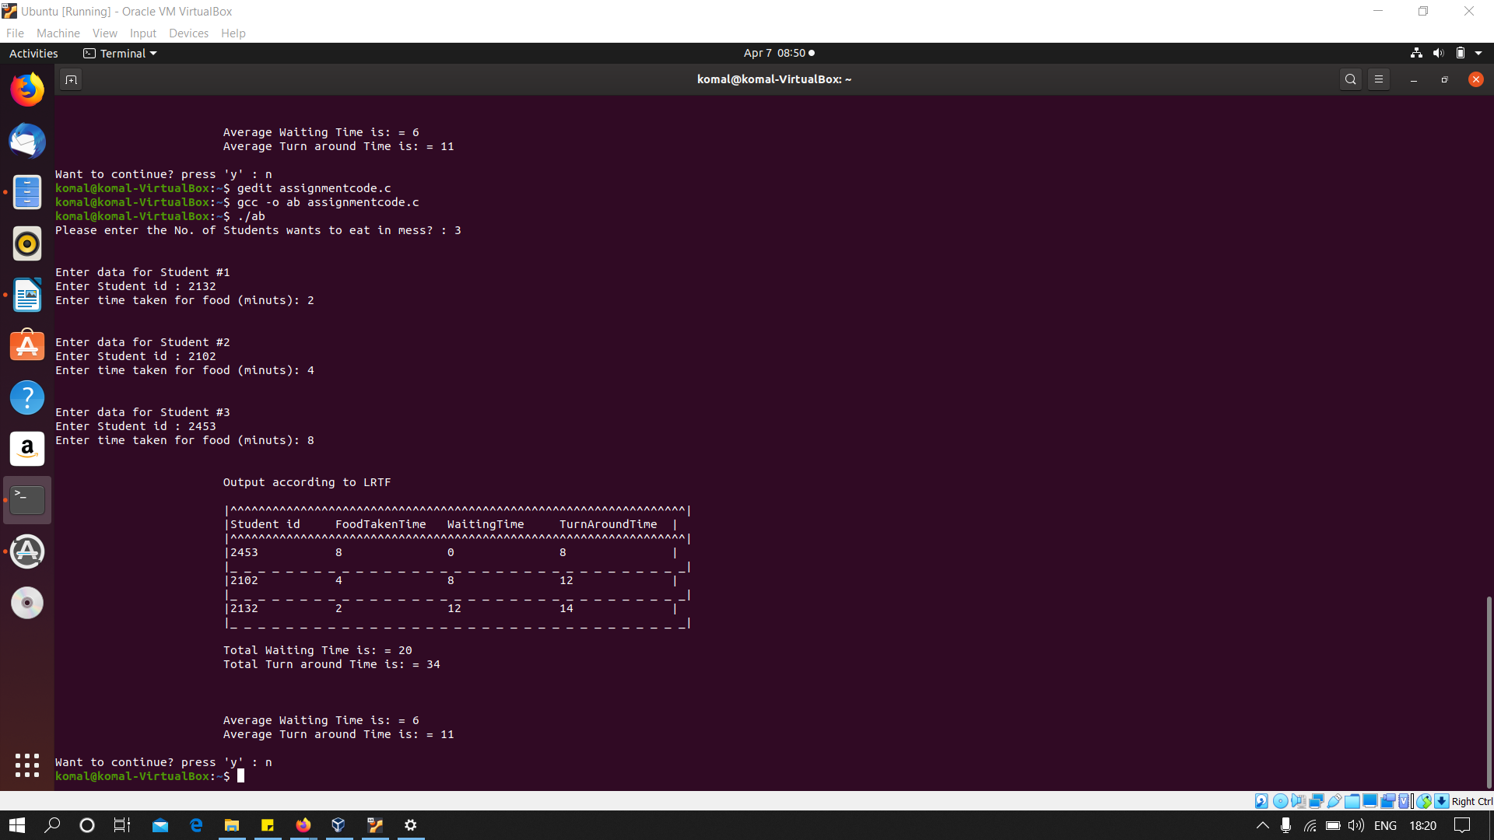

#######################################END#######################################

